RED KNIGHTS MOTORCYCLE CLUB ®
Alberta Chapter 12
Shane Straty - QUARTERMASTER
2309 14 Street
Wainwright, Alberta, Canda, T9W 0C4
Tel. 780-646-2157
E-Mail: abchapter12@hotmail.com
TMLA File Number – AB 12-02

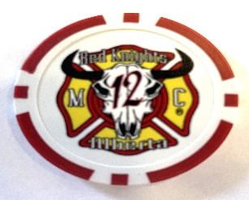
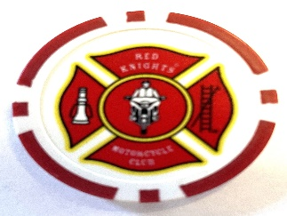

2 Sided Ceramic Poker Chip (1.5 inch) with International Logo on the front and Alberta Chapter 12 logo on the back. Pay Pal is accepted. E-mail for information/shipping rates.

☐Automotive
☐Automotive-Misc
☐Automotive-Motorcycle
☐Coin, Patches, Pins
☐Clothing
☐Clothing-Hats
☐Clothing-Misc
☐Clothing-Vest/Vest Items
☐Clothing-Women’s
☐Decals/Stickers
☐Flags
☐Housewares-Beverage Items
☐Housewares-Misc.
☒Misc. Items

Item | Description | Color | Quantity | Cost ea. | Total
1 | Chapter Poker Chip |  |  | $5.00
2
3
Sub Total
Shipping and handling fees (if any)
Total
Please make check/money order out to RKMC Alberta Chapter 12.
PAYPAL – undertaker@telus.net
All Prices Canadian Currency / Prices subject to change without notice
All Items must be pre-paid

